Coursework 3 – Barnaby’s Brewhouse

Code:

""" python script to provide sales predictions for Barnaby's Brewhouse by

analysis of previous sales data, and facilitate inventory management and beer

production planning """

# import libraries

from tkinter import filedialog

from tkinter import*

import matplotlib.pyplot as plt

from datetime import datetime, date

import tkinter.messagebox

from functools import partial

import logging

def get_data() -> dict:

""" retrieve the sales data from the CSV file """

# open the file and read the data

with open("files/sales.csv", "r") as data_file:

read_file = data_file.readlines()

data = {}

# split the data from each line by commas, and append it to the data

# list

fields = read_file[0].rstrip("\n").split(",")

for n in range(6):

data[fields[n]] = []

for line in read_file:

if line != read_file[0]:

try:

data_in_line = line.rstrip("\n").split(",")

data_in_line[4] = str(int(data_in_line[4]))

for n in range(6):

data[fields[n]].append(data_in_line[n])

except:

continue

return data

def plot_data() -> None:

""" create a graph of the sales data """

month_data = get_month_data()

data = []

xlabel = []

# create the data array for the x axis

for key in month_data:

data.append(month_data[key])

xlabel.append(key)

# plot the graph and label the axis

plt.bar(xlabel, data, color="#b3ecff")

plt.ylabel('Sales')

plt.xlabel('Month')

plt.show()

def get_month_data() -> dict:

""" find sales data per month """

# get the relevant data from the file

data = get_data()

sales_data = data["Quantity ordered"]

date_data = data["Date Required"]

# add up the quantities sold for each month

month_data = {}

for q_index in range(len(sales_data)):

sales_no = sales_data[q_index]

date = date_data[q_index]

month = date[3:6]

try:

month_data[month] += int(sales_no)

except:

month_data[month] = int(sales_no)

return month_data

def capitalise_first(string: str) -> str:

""" capitalise the first letter of a string """

# split the string, capitalise the first letter and rejoin it

string = list(string)

string[0] = string[0].upper()

string = ''.join(string)

return string

def predict_new() -> int:

""" predict a new value for the sales demand next month """

month_data = get_month_data()

# create a dictionary of each month and the ratio to the next month

ratios_dict = {}

for month in MONTHS:

month_index = MONTHS.index(month)

month = capitalise_first(month)

next_month = MONTHS[(month_index+1) % 12]

next_month = capitalise_first(next_month)

ratio = month_data[next_month]/month_data[month]

ratios_dict[month] = ratio

# get the names of the current month and the next month

calculate_date = datetime.now()

calculate_date = str(calculate_date)[5:7]

previous_date = MONTHS[(int(calculate_date)-2) % 12]

current_date = MONTHS[(int(calculate_date)-1) % 12]

calculate_date = MONTHS[int(calculate_date) % 12]

previous_date = capitalise_first(previous_date)

current_date = capitalise_first(current_date)

calculate_date = capitalise_first(calculate_date)

# get the ratio for both months, and predict the next demand

calculate_ratio = ratios_dict[calculate_date]

current_ratio = ratios_dict[current_date]

# the prediction is last month's data multiplied by the ratio for

# each month

input_sales = month_data[previous_date]

this_prediction = int(input_sales)*current_ratio

next_prediction = this_prediction*calculate_ratio

# display these results on the GUI

this_text.set(str(int(int(this_prediction)/2))+" litres")

next_text.set(str(int(int(next_prediction)/2))+" litres")

def get_data_list() -> list:

""" return the same information as get_data, but in a list form """

# get the data dictionary

data_dict = get_data()

# put each item of the dictionary into a list

data_list_row = []

for key in data_dict:

data_list_row.append(data_dict[key])

data_list = []

# create blank lists for each list to go into the data list

for l in range(len(data_list_row[0])):

data_list.append([])

# put each item from the rows in data_list_row into the list. We now have

# the data in the format [[invoice no. 1, customer 1, date 1, etc...],...]

for i in range(len(data_list_row)):

for n in range(len(data_list_row[i])):

data_list[n].append(data_list_row[i][n])

# check whether the data is in the correct format

for value in data_list:

try:

value[2] = datetime.strptime(value[2], "%d-%b-%y")

except:

debug = "Date for {} stored in the wrong format".format(value[0])

logger.debug(debug)

# sort the list into chronological order

sorted(data_list, key=lambda x: data_list[2])

return data_list

def get_beer_ratios(type: int) -> list:

""" returns the ratios of the beers, and the total number of each beer """

# type is a variable used to represent whether the calculation is to be

# done for this month (0), or the next month (1)

# work out the current month as a nyumber, e.g. January = 1

if type == 0:

comparison_text = this_text.get().rstrip(" litres")

comparison = int(comparison_text)

offset = 0

current_date = date.today().strftime("%B")

# work out the next month as a number

else:

comparison_text = next_text.get().rstrip(" litres")

comparison = int(comparison_text)

offset = 1

current_date = (date.today().month+1) % 12

current_date = datetime(year=1, month=current_date, day=1)

current_date = current_date.strftime("%B")

# get the data as a list

data = get_data_list()

beers = {}

# for each sale, if the date matches the date that we are counting for,

# add one to a counter which is stored with that month

for entry in data:

try:

match_date = MONTHS[(entry[2].month)-1]

except:

day = int(entry[2][0:2])

month = entry[2][3:6]

year = int(entry[2][7:])

month = MONTHS.index(month.lower())

entry[2] = datetime(year=year, month=month, day=day)

match_date = MONTHS[(entry[2].month)-1]

if current_date.lower()[0:3] == match_date:

beer_name = entry[3]

try:

beers[beer_name] += 1

except:

beers[beer_name] = 1

# add all the beers to the beer_list, and all the corresponding totals to

# total_list

beer_list = []

total_list = []

for beer in beers:

beer_list.append(beer)

total_list.append(beers[beer])

# find the total number of sales

total = 0

for value in total_list:

total += value

# calculate each ratio from month to month

beer_ratios = []

for value in total_list:

ratio = comparison * (value/total)

beer_ratios.append(int(ratio))

return beer_ratios, beer_list

def get_info(type: int) -> None:

""" creates a window which displays the number of each beers to be made """

# get the beers and ratios

beer_ratios, beer_list = get_beer_ratios(type)

# create the window

info_window = Toplevel(bg="#515151")

info_window.geometry("210x75")

# create labels for each beer

n = 0

for beer in beer_list:

beer_1 = Label(info_window,

text=beer+": "+str(beer_ratios[n])+" litres")

beer_1.grid(row=n, column=0)

beer_1.config(bg="#515151", fg="white", font=("Arial Black", "10"))

n += 1

def verify_date(date: str) -> datetime:

""" checks whether a date is in the correct format. If it is, return the

date, otherwise, return False"""

try:

# check to see if the date can be parsed correctly

date_str = date

date_datetime = datetime.strptime(date_str, "%d-%b-%Y")

return date

except:

return False

def submit_sale(window_widgets: list, sale_window: tkinter.Toplevel) -> None:

""" the user will enter a sale and this functio will validate it, and update

the system with the effects of the sale """

# get all the values from the input boxes

invoice = window_widgets[0].get()

customer = window_widgets[1].get()

date = window_widgets[2].get()

beer = window_widgets[3]

gyle = window_widgets[4].get()

quantity = window_widgets[5].get()

logger.info("Sale submitted")

# put the values in a list

info_list = [invoice, customer, date, beer, gyle, quantity]

# check whether all the number fields are numbers

try:

invoice = str(int(invoice))

gyle = str(int(gyle))

quantity = str(int(quantity))

except:

# return an error message

logger.info("Sale submit incorrectly - invalid string")

tkinter.messagebox.showinfo("Error", "Please input a valid entry")

return None

# check the format of the date

date_verification = verify_date(date)

if date_verification is False:

# return an error message

logger.info("Sale submit incorrectly - Date format incorrect")

tkinter.messagebox.showinfo("Error",

("Please enter date in the format \n",

"DD-Month-YYYY"))

return None

# check whether all the boxes are filled in

for item in info_list:

if item == "":

logger.info("Sale submit incorrectly - Missing value")

tkinter.messagebox.showinfo("Error",

"Please enter a value in all fields")

return None

beer = beer.get()

# add to CSV file

try:

# update the stocks

stock_updated = update_stock(beer, -int(quantity))

if stock_updated:

sale_window.destroy()

logger.info("Sale logged successfully")

else:

raise ValueError

csv_file = open("files/sales.csv", "a")

write_string = ""

for n in range(len(info_list)-1):

write_string += str(info_list[n])+","

write_string += info_list[len(info_list)-1]

write_string += "\n"

csv_file.write(write_string)

csv_file.close()

except:

logger.error("Failed to log sale - file is being edited")

tkinter.messagebox.showinfo("Error", "Please close the sales file")

def add_sale() -> None:

""" creates a window where the user can register a sale """

# create the fields and submit button

sale_window = Toplevel(bg="#515151")

sale_window.geometry("800x100")

invoice = Label(sale_window, text="Invoice No.")

invoice.grid(row=1, column=0)

invoice.config(bg="#515151", fg="white", font=("Arial Black", "10"))

invoice_field = Entry(sale_window)

invoice_field.grid(row=2, column=0, sticky="NSEW")

customer = Label(sale_window, text="Customer")

customer.grid(row=1, column=1, sticky="NSEW")

customer.config(bg="#515151", fg="white", font=("Arial Black", "10"))

customer_field = Entry(sale_window)

customer_field.grid(row=2, column=1, sticky="NSEW")

date = Label(sale_window, text="Date - DD-Month-YYYY")

date.grid(row=1, column=2, sticky="NSEW")

date.config(bg="#515151", fg="white", font=("Arial Black", "10"))

date_field = Entry(sale_window)

date_field.grid(row=2, column=2, sticky="NSEW")

beer = Label(sale_window, text="Recipe")

beer.grid(row=1, column=3, sticky="NSEW")

beer.config(bg="#515151", fg="white", font=("Arial Black", "10"))

beer_select = StringVar()

beer_field = OptionMenu(sale_window, beer_select, "Organic Red Helles",

"Organic Pilsner", "Organic Dunkel")

beer_field.grid(row=2, column=3, sticky="NSEW")

gyle = Label(sale_window, text="Gyle No.")

gyle.grid(row=1, column=4, sticky="NSEW")

gyle.config(bg="#515151", fg="white", font=("Arial Black", "10"))

gyle_field = Entry(sale_window)

gyle_field.grid(row=2, column=4, sticky="NSEW")

quantity = Label(sale_window, text="Quantity")

quantity.grid(row=1, column=5, sticky="NSEW")

quantity.config(bg="#515151", fg="white", font=("Arial Black", "10"))

quantity_field = Entry(sale_window)

quantity_field.grid(row=2, column=5, sticky="NSEW")

window_widgets = [invoice_field, customer_field, date_field, beer_select,

gyle_field, quantity_field]

submit = Button(sale_window, text="Submit",

command=lambda: submit_sale(window_widgets, sale_window))

submit.grid(row=3, column=0, sticky="NSEW")

submit.config(fg="#515151", bg="#b3ecff", font=("Arial Black", "10"))

def start_machine(arguments: list) -> None:

""" changes the status of the machine to be running """

machine = arguments[0]

machine_label = arguments[1]

# check if the machine is empty, in which case it cannot run.

if machines[machine][1] != "":

machines[machine][5] = "Running"

machine_label.config(fg="green")

else:

tkinter.messagebox.showinfo("Error", "Machine is empty")

def create_widgets(view_window: tkinter.Toplevel) -> None:

""" refresh the widgets in the view window """

# clear the existing widgets

widget_list = view_window.winfo_children()

for item in widget_list:

if item.winfo_children():

widget_list.extend(item.winfo_children())

for item in widget_list:

item.grid_forget()

# make the machine labels and start buttons

n = 2

machine_labels = []

for machine in machines:

message = machine+": "+machines[machine][0]+": "+machines[machine][1]

machine_label = Label(view_window, text=message)

machine_label.grid(row=n, column=0)

machine_label.config(bg="#515151", fg="white",

font=("Arial Black", "10"))

machine_button = Button(view_window, text="Start")

machine_button.grid(row=n, column=1)

machine_button.config(command=partial(start_machine,

[machine, machine_label]),

fg="#515151", bg="#b3ecff",

font=("Arial Black", "10"))

machine_labels.append(machine_label)

n += 1

# make the batch labels and buttons

batch_title = Label(view_window, text="Batch Status:")

batch_title.grid(row=n, column=0, sticky="W")

batch_title.config(bg="#515151", fg="white", font=("Arial Black", "10"))

n += 1

for batch in status:

if status[batch] != []:

message = batch+": "+status[batch][0]

batch_label = Label(view_window, text=message)

batch_label.grid(row=n, column=0)

batch_label.config(bg="#515151", fg="white",

font=("Arial Black", "10"))

batch_button = Button(view_window, text="Next Stage")

batch_button.config(command=partial(next_stage,

[batch, batch_label,

batch_button, view_window,

machine_labels]),

fg="#515151", bg="#b3ecff",

font=("Arial Black", "10"))

batch_button.grid(row=n, column=1, sticky="NSEW")

n += 1

add_button = Button(view_window, text="Edit Brewing Process",

command=lambda: add_process(machine_labels,

view_window))

add_button.grid(row=0, column=0, sticky="NSEW")

add_button.config(fg="#515151", bg="#b3ecff", font=("Arial Black", "10"))

brewers_title = Label(view_window, text="Brewing Tank Status:")

brewers_title.config(bg="#515151", fg="white", font=("Arial Black", "10"))

brewers_title.grid(row=1, column=0, sticky="W")

def submit_entry(view_window: tkinter.Toplevel, beer: str, gyle: str,

quantity: str) -> None:

""" validate the entry of the beer into a machine and change the status

of the batch to be the first stage of the brewing process """

# raise an error if there is an empty box

if beer == "" or gyle == "" or quantity == "":

tkinter.messagebox.showinfo("Error, please fill out all fields")

# raise an error if the gyle number is not unique

elif gyle in status:

tkinter.messagebox.showinfo("Error, gyle number must be unique")

else:

# is the gyle number a number

try:

gyle = str(int(gyle))

# if no error, then set the batch to hot brew, and refresh

# the window

create_widgets(view_window)

save()

except:

# raise an error

logger.info("Batch load unsuccesful - Gyle is a number")

tkinter.messagebox.showinfo("Error, gyle number must be a number")

# repeat for the quantity

try:

quantity = str(int(quantity))

status[gyle] = ["Hot Brew", beer, quantity]

logger.info("Batch {} loaded successfully".format(gyle))

create_widgets(view_window)

save()

except:

logger.info("Batch load unsuccesful - Quantity is a number")

tkinter.messagebox.showinfo("Error, quantity must be a number")

def machine_clear(batch: str, view_window: tkinter.Toplevel,

machine_labels: list) -> None:

""" clear the machine and set its status to running """

# clear the machine and set its status to running

for machine in machines:

if batch in machines[machine][1]:

machine_list = [machine for machine in machines]

machines[machine][1] = ""

machines[machine][2] = ""

machines[machine][4] = 0

machines[machine][5] = "Waiting"

index = machine_list.index(machine)

machine_labels[index].config(fg="white")

logger.info("Machine {} was cleared of {}".format(machine, batch))

# save the files and refresh the window

save()

create_widgets(view_window)

def find_machine(batch: str, view_window: tkinter.Toplevel, type: str) -> str:

""" find an appropraite machine for the batch """

# find the volumne of the batch

batch_info = status[batch]

volume = float(batch_info[2])*0.5

# find machines that aren't waiting, and can perform the correct job

possible_machines = []

for machine in machines:

if type in machines[machine][0]:

if machines[machine][5] == "Waiting":

possible_machines.append(machine)

machines_list = [machine for machine in possible_machines]

n = 0

# for every machine in possible machines, check whether it can take the job

while n < len(machines_list):

info = machines[machines_list[n]]

# if there is no space in the machine, move on

if float(info[4])+volume > float(info[3]):

n += 1

continue

keys = [machine for machine in machines]

machine_index = keys.index(machine)

# if the machine is empty, add it

if info[2] == "":

return machines_list[n]

# if the machine has the same recipe in it, add it

elif batch_info[0] in info[2]:

return machines_list[n]

n += 1

logger.info("All machines full or in use")

tkinter.messagebox.showinfo("Error", "No Machines Available")

return "None"

def machine_load(batch: str, view_window: tkinter.Toplevel, type: str) -> None:

""" load a batch into a machine """

# get an available

machine = find_machine(batch, view_window, type)

if machine != "None":

# change the attributes of the machine

new_info = [batch, status[batch][1], status[batch][2]]

machines[machine][1] += " "+batch

machines[machine][2] += status[batch][1]

status_2 = int(status[batch][2])

machines_4 = float(machines[machine][4])

machines[machine][4] = machines_4+status_2

# save the changes and update the window

logger.info("{} loaded into {}".format(batch, machine))

save()

create_widgets(view_window)

def next_stage(arguments: list) -> None:

""" move the batch onto the next stage of the brewing process """

# unpack the arguments

batch = arguments[0]

label = arguments[1]

button = arguments[2]

view_window = arguments[3]

machine_labels = arguments[4]

# find the current stage of the batch

current_stage = status[batch][0]

if current_stage == "Bottling":

# remove the batch from the window

update_stock(status[batch][1], status[batch][2])

status.pop(batch)

button.grid_forget()

label.grid_forget()

save()

return None

# find the stage

stage_index = PROCESS.index(current_stage)

next_process = PROCESS[stage_index+1]

if next_process == "Bottling":

for machine in machines:

current_machine = machines[machine]

if current_machine[5] == "Waiting" and batch in current_machine[1]:

tkinter.messagebox.showinfo("Error. Machine is not running")

logger.info("{} finished brewing".format(batch))

return None

# remove it from the machine

machine_clear(batch, view_window, machine_labels)

status[batch][0] = next_process

new_text = batch+": "+next_process

label.config(text=new_text)

logger.info("{} is now at stage {}".format(batch, next_process))

elif next_process == "Fermentation":

# load the batch

machine_load(batch, view_window, "Fermenter")

# update the batch's status

status[batch][0] = next_process

new_text = batch+": "+next_process

label.config(text=new_text)

logger.info("{} is now at stage {}".format(batch, next_process))

elif next_process == "Conditioning":

# check if the machine is running

machine_list = [machine for machine in machines]

for machine in machines:

current_machine = machines[machine]

if current_machine[5] == "Waiting" and batch in current_machine[1]:

tkinter.messagebox.showinfo("Error. Machine is not running")

return None

# load it into a fermenter

machine_clear(batch, view_window, machine_labels)

machine_load(batch, view_window, "Conditioner")

# update the batch's status

status[batch][0] = next_process

new_text = batch+": "+next_process

label.config(text=new_text)

logger.info("{} is now at stage {}".format(batch, next_process))

create_widgets(view_window)

save()

refresh()

def add_process(machine_labels: list, view_window: tkinter.Toplevel) -> None:

""" creates a window to allow the user to add a process """

# make the window

add_window = Toplevel(bg="#515151")

# make the fields

beer = Label(add_window, text="Recipe")

beer.grid(row=1, column=0, sticky="NSEW")

beer.config(bg="#515151", fg="white", font=("Arial Black", "10"))

beer_select = StringVar()

beer_field = OptionMenu(add_window, beer_select, "Organic Red Helles",

"Organic Pilsner", "Organic Dunkel")

beer_field.grid(row=2, column=0, sticky="NSEW")

gyle = Label(add_window, text="Gyle No.")

gyle.grid(row=1, column=1, sticky="NSEW")

gyle.config(bg="#515151", fg="white", font=("Arial Black", "10"))

gyle_field = Entry(add_window)

gyle_field.grid(row=2, column=1, sticky="NSEW")

quantity = Label(add_window, text="Quantity")

quantity.grid(row=1, column=2, sticky="NSEW")

quantity.config(bg="#515151", fg="white", font=("Arial Black", "10"))

quantity_field = Entry(add_window)

quantity_field.grid(row=2, column=2, sticky="NSEW")

info_widget_list = [beer_field, gyle_field, quantity_field]

submit = Button(add_window, text="Submit",

command=lambda: submit_entry(view_window,

beer_select.get(),

gyle_field.get(),

quantity_field.get()))

submit.config(fg="#515151", bg="#b3ecff", font=("Arial Black", "10"))

submit.grid(row=3, column=0, sticky="NSEW")

def view_process() -> None:

""" creates a window to view the machines and batches in """

view_window = Toplevel(bg="#515151")

create_widgets(view_window)

def save() -> None:

''' save the contents of the machines and batches so that they can be

restored later '''

# clear both files

machines_write = open("files/machines.txt", "w")

machines_write.close()

batches_write = open("files/batches.txt", "w")

batches_write.close()

# update the files

machines_file = open("files/machines.txt", "a")

for machine in machines:

machine_string = machine

for m in machines[machine]:

machine_string += ","+str(m)

machines_file.write(machine_string+"\n")

machines_file.close()

batches_file = open("files/batches.txt", "a")

for batch in status:

batch_string = batch

for b in status[batch]:

batch_string += ","+str(b)

batches_file.write(batch_string+"\n")

batches_file.close()

logger.info("Saved")

def update_stock(recipe: str, value: str) -> bool:

""" change the value stored in the stock array """

# find the index of the beer

stock_index = RECIPES.index(recipe)

# update the value

new_stock = stocks[stock_index] - int(value)

if new_stock < 0:

logger.error("Stock cannot be negative")

return False

stocks[stock_index] += int(value)

get_stocks()

save_stock()

logger.info("Stock updated {} {} {}".format("Red Helles: "+str(stocks[0]),

"Pilsner: "+str(stocks[1]),

"Dunkel: "+str(stocks[2])))

return True

def recommend_beer() -> None:

""" recommends the beer to be brewed next """

# get information

beer = ""

ratio_1, beer_1 = get_beer_ratios(0)

ratio_2, beer_2 = get_beer_ratios(1)

considered = [False, False, False]

for n in range(3):

# if the stock level is below 100, recommend that it is brewed

if stocks[n] < 100:

beer = RECIPES[n]

recommended.config(text=beer)

# if the stock is less than required, consider it to be recommended

if stocks[n] <= ratio_1[n]+ratio_2[n]:

considered[n] = ratio_1[n]+ratio_2[n]-stocks[n]

# if the beer hasn't been selected yet

if beer == "":

considered_length = [num for num in considered if num is not False]

# if no beer is understocked, recommend the beer with the lowest stock

if len(considered_length) == 0:

beer_index = stocks.index(min(stocks))

else:

# find the biggest difference between the required amount and the

# current stock, and recommned that beer

maximum = max(considered)

beer_index = considered.index(maximum)

beer = RECIPES[beer_index]

recommended.config(text=beer)

logger.info("{} recommended to brew".format(beer))

window.update()

def get_stocks() -> None:

""" set the text and colour of the stock attributes """

helles_text.set(str(stocks[0]))

pilsner_text.set(str(stocks[1]))

dunkel_text.set(str(stocks[2]))

if stocks[0] < 100:

helles_stock.config(fg="red")

else:

helles_stock.config(fg="white")

if stocks[1] < 100:

pilsner_stock.config(fg="red")

else:

pilsner_stock.config(fg="white")

if stocks[2] < 100:

dunkel_stock.config(fg="red")

else:

dunkel_stock.config(fg="white")

def refresh() -> None:

""" run the functions to refresh the main page """

get_stocks()

predict_new()

recommend_beer()

def save_stock() -> None:

""" rewrite the stocks file """

stock_file = open("files/stocks.txt", "w")

stock_file.write(str(stocks[0])+","+str(stocks[1])+","+str(stocks[2])+"\n")

stock_file.close()

logger.info("Stock saved")

PROCESS = ["Hot Brew", "Fermentation", "Conditioning", "Bottling"]

# unpack from the stocks file

status = {}

status_file = open("files/batches.txt", "r")

status_read = status_file.readlines()

for line in status_read:

line_split = line.rstrip("\n").split(",")

status_key = line_split[0]

if status_key != "":

line_split.remove(line_split[0])

status[status_key] = [line_split[0], line_split[1], line_split[2]]

status_file.close()

# machines dictionary stores name, type, batches in the machine, capacity and

# current volume

machines = {}

machine_file = open("files/machines.txt", "r")

machine_read = machine_file.readlines()

for line in machine_read:

line_split = line.rstrip("\n").split(",")

machine_key = line_split[0]

line_split.remove(line_split[0])

machines[machine_key] = line_split

machine_file.close()

stock_file = open("files/stocks.txt", "r")

stock_read = stock_file.readlines()

stocks = stock_read[0].rstrip("\n").split(",")

stocks = [int(stock) for stock in stocks]

stock_file.close()

MONTHS = ["jan", "feb", "mar", "apr", "may", "jun", "jul", "aug", "sep",

"oct", "nov", "dec"]

FULL_MONTHS = ["January", "February", "March", "April", "May", "June", "July",

"August", "September", "October", "November", "December"]

info_widgets = {}

RECIPES = ["Organic Red Helles", "Organic Pilsner", "Organic Dunkel"]

logger = logging.getLogger(__name__)

logger.setLevel(logging.DEBUG)

file_handler = logging.FileHandler('files/logfile.log')

logging_format = '%(asctime)s : %(levelname)s : %(name)s : %(message)s'

formatter = logging.Formatter(logging_format)

file_handler.setFormatter(formatter)

logger.addHandler(file_handler)

# GUI setup

window = Tk()

window.geometry("575x325")

window.config(bg="#515151")

window.title("Barnaby's Brewhouse")

title = Label(window, text="BARNABY'S BREWHOUSE")

title.grid(row=0, column=0, sticky="NSEW", columnspan=3)

title.config(bg="#515151", fg="white", font=("Arial", 28))

calculate_date = datetime.now()

calculate_date = str(calculate_date)[5:7]

current_date = FULL_MONTHS[(int(calculate_date)-1) % 12]

calculate_date = FULL_MONTHS[int(calculate_date) % 12]

this_month = Label(window, text="Demand for "+current_date+":")

this_month.grid(row=2, column=0, sticky="NSEW")

this_month.config(bg="#515151", fg="white", font=("Arial Black", "10"))

this_info = Button(window, text="More Info", command=lambda: get_info(0))

this_info.grid(row=4, column=0, sticky="NSEW")

this_info.config(fg="#515151", bg="#b3ecff", font=("Arial Black", "10"))

next_info = Button(window, text="More Info", command=lambda: get_info(1))

next_info.grid(row=4, column=1, sticky="NSEW")

next_info.config(fg="#515151", bg="#b3ecff", font=("Arial Black", "10"))

next_month = Label(window, text="Demand for "+calculate_date+":")

next_month.grid(row=2, column=1, sticky="NSEW")

next_month.config(bg="#515151", fg="white", font=("Arial Black", "10"))

this_text = StringVar()

this_value = Label(window, textvariable=this_text)

this_value.grid(row=3, column=0, sticky="NSEW")

this_value.config(bg="#515151", fg="white", font=("Arial Black", "10"))

next_text = StringVar()

next_value = Label(window, textvariable=next_text)

next_value.grid(row=3, column=1, sticky="NSEW")

next_value.config(bg="#515151", fg="white", font=("Arial Black", "10"))

graph_button = Button(window, text="Plot Monthly Data", command=plot_data)

graph_button.grid(row=5, column=0, sticky="NSEW")

graph_button.config(fg="#515151", bg="#b3ecff", font=("Arial Black", "10"))

manage_button = Button(window, text="Add Data", command=add_sale)

manage_button.grid(row=6, column=0, sticky="NSEW")

manage_button.config(fg="#515151", bg="#b3ecff", font=("Arial Black", "10"))

view_button = Button(window, text="View Brewing Process", command=view_process)

view_button.grid(row=7, column=0, sticky="NSEW")

view_button.config(fg="#515151", bg="#b3ecff", font=("Arial Black", "10"))

pilsner_label = Label(window, text="Organic Pilsner Stock:")

pilsner_label.grid(row=8, column=0, sticky="NSEW")

pilsner_label.config(bg="#515151", fg="white", font=("Arial Black", "10"))

pilsner_text = StringVar()

pilsner_stock = Label(window, textvariable=pilsner_text)

pilsner_stock.grid(row=9, column=0, sticky="NSEW")

pilsner_stock.config(bg="#515151", fg="white", font=("Arial Black", "10"))

helles_label = Label(window, text="Organic Red Helles Stock:")

helles_label.grid(row=8, column=1, sticky="NSEW")

helles_label.config(bg="#515151", fg="white", font=("Arial Black", "10"))

helles_text = StringVar()

helles_stock = Label(window, textvariable=helles_text)

helles_stock.grid(row=9, column=1, sticky="NSEW")

helles_stock.config(bg="#515151", fg="white", font=("Arial Black", "10"))

dunkel_label = Label(window, text="Organic Dunkel Stock:")

dunkel_label.grid(row=8, column=2, sticky="NSEW")

dunkel_label.config(bg="#515151", fg="white", font=("Arial Black", "10"))

dunkel_text = StringVar()

dunkel_stock = Label(window, textvariable=dunkel_text)

dunkel_stock.grid(row=9, column=2, sticky="NSEW")

dunkel_stock.config(bg="#515151", fg="white", font=("Arial Black", "10"))

get_stocks()

recommend_label = Label(window, text="Recommended beer to brew:")

recommend_label.grid(row=10, column=0, sticky="NSEW")

recommend_label.config(bg="#515151", fg="white", font=("Arial Black", "10"))

recommended = Label(window, text="")

recommended.grid(row=10, column=1, sticky="NSEW")

recommended.config(bg="#515151", fg="white", font=("Arial Black", "10"))

refresh_button = Button(window, text="Refresh", command=refresh)

refresh_button.grid(row=11, column=0, sticky="NSEW")

refresh_button.config(fg="#515151", bg="#b3ecff", font=("Arial Black", "10"))

predict_new()

recommend_beer()

logger.info("System started successfully")

window.mainloop()

Main Interface:

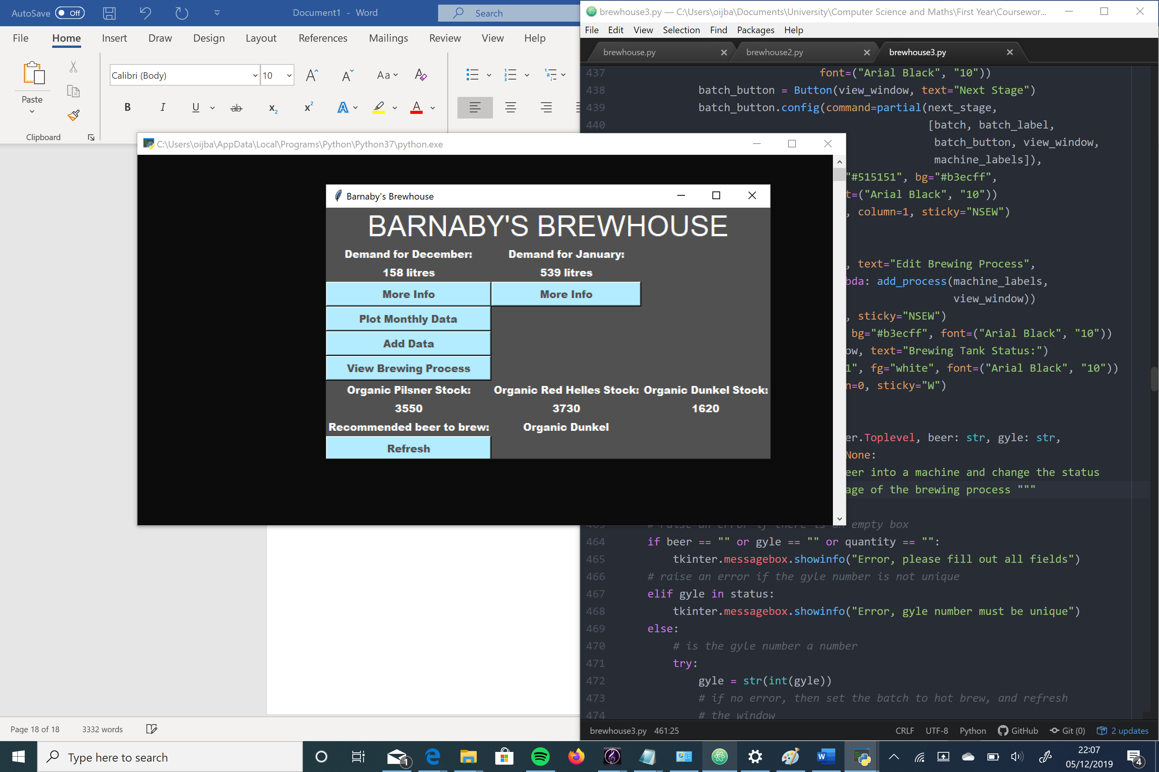

More Info:

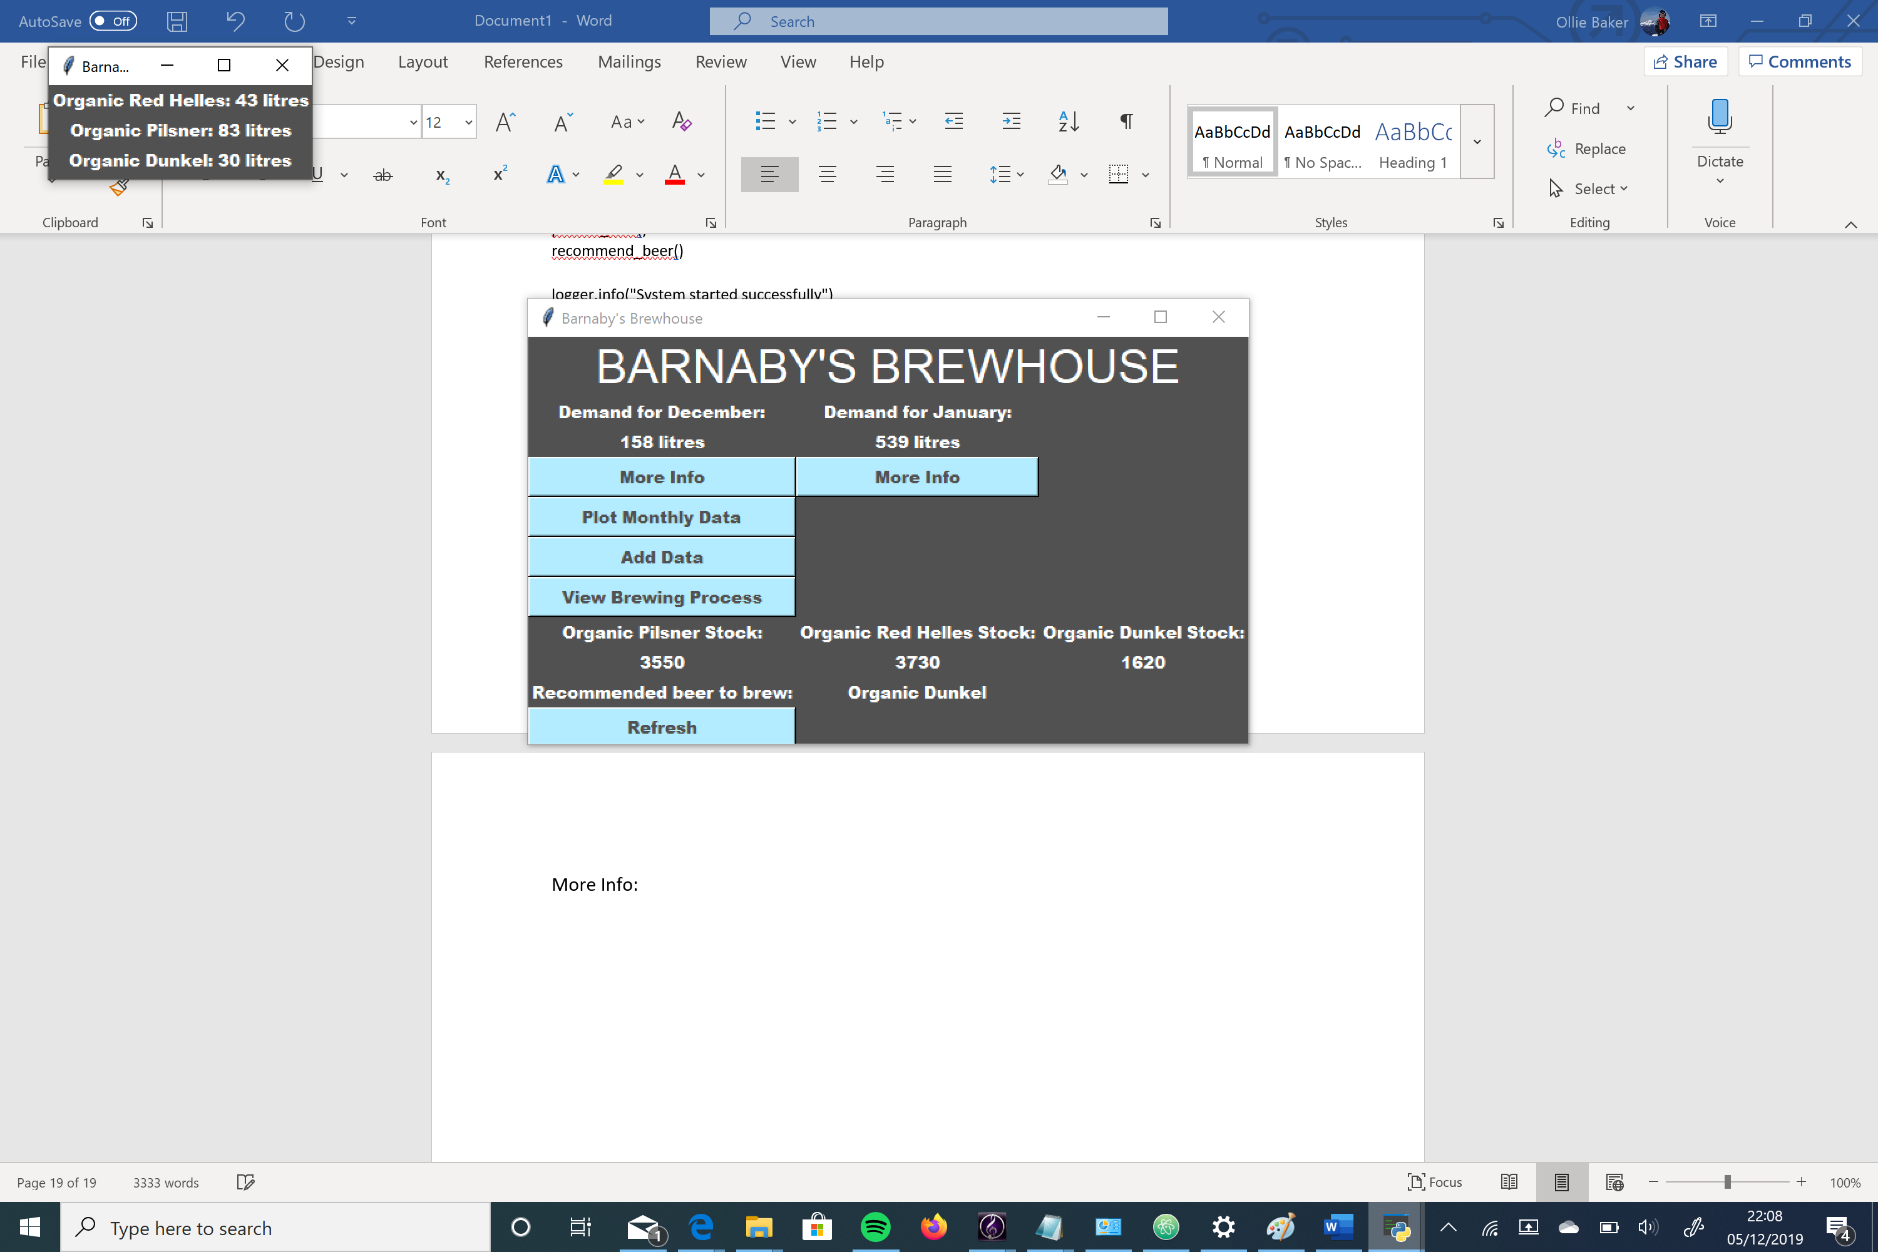

Plot Data:

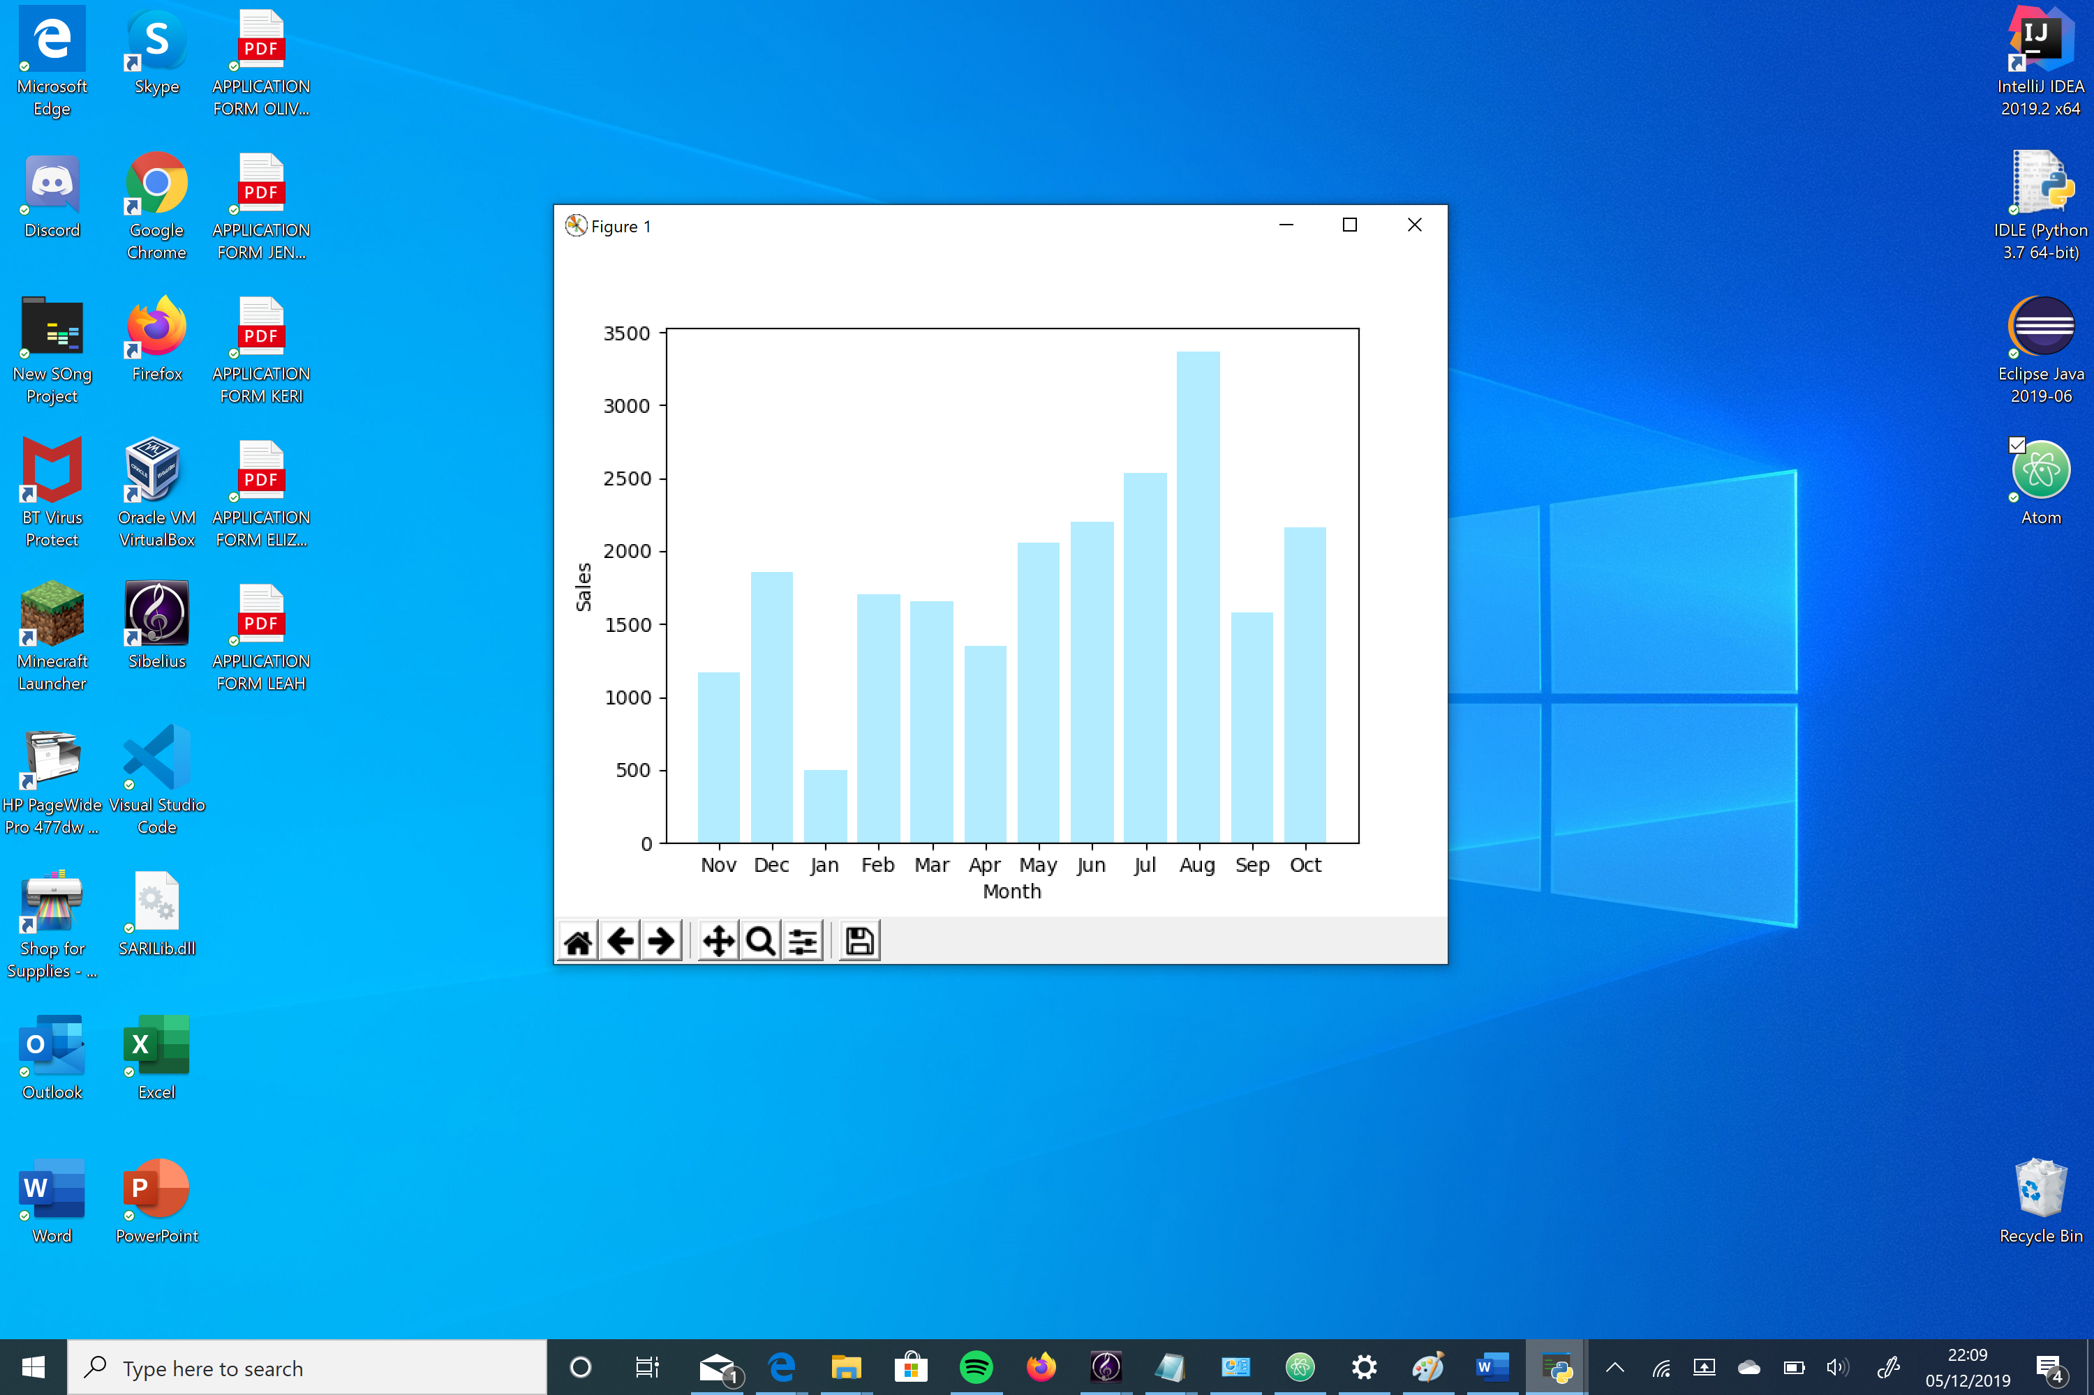

Add Data:

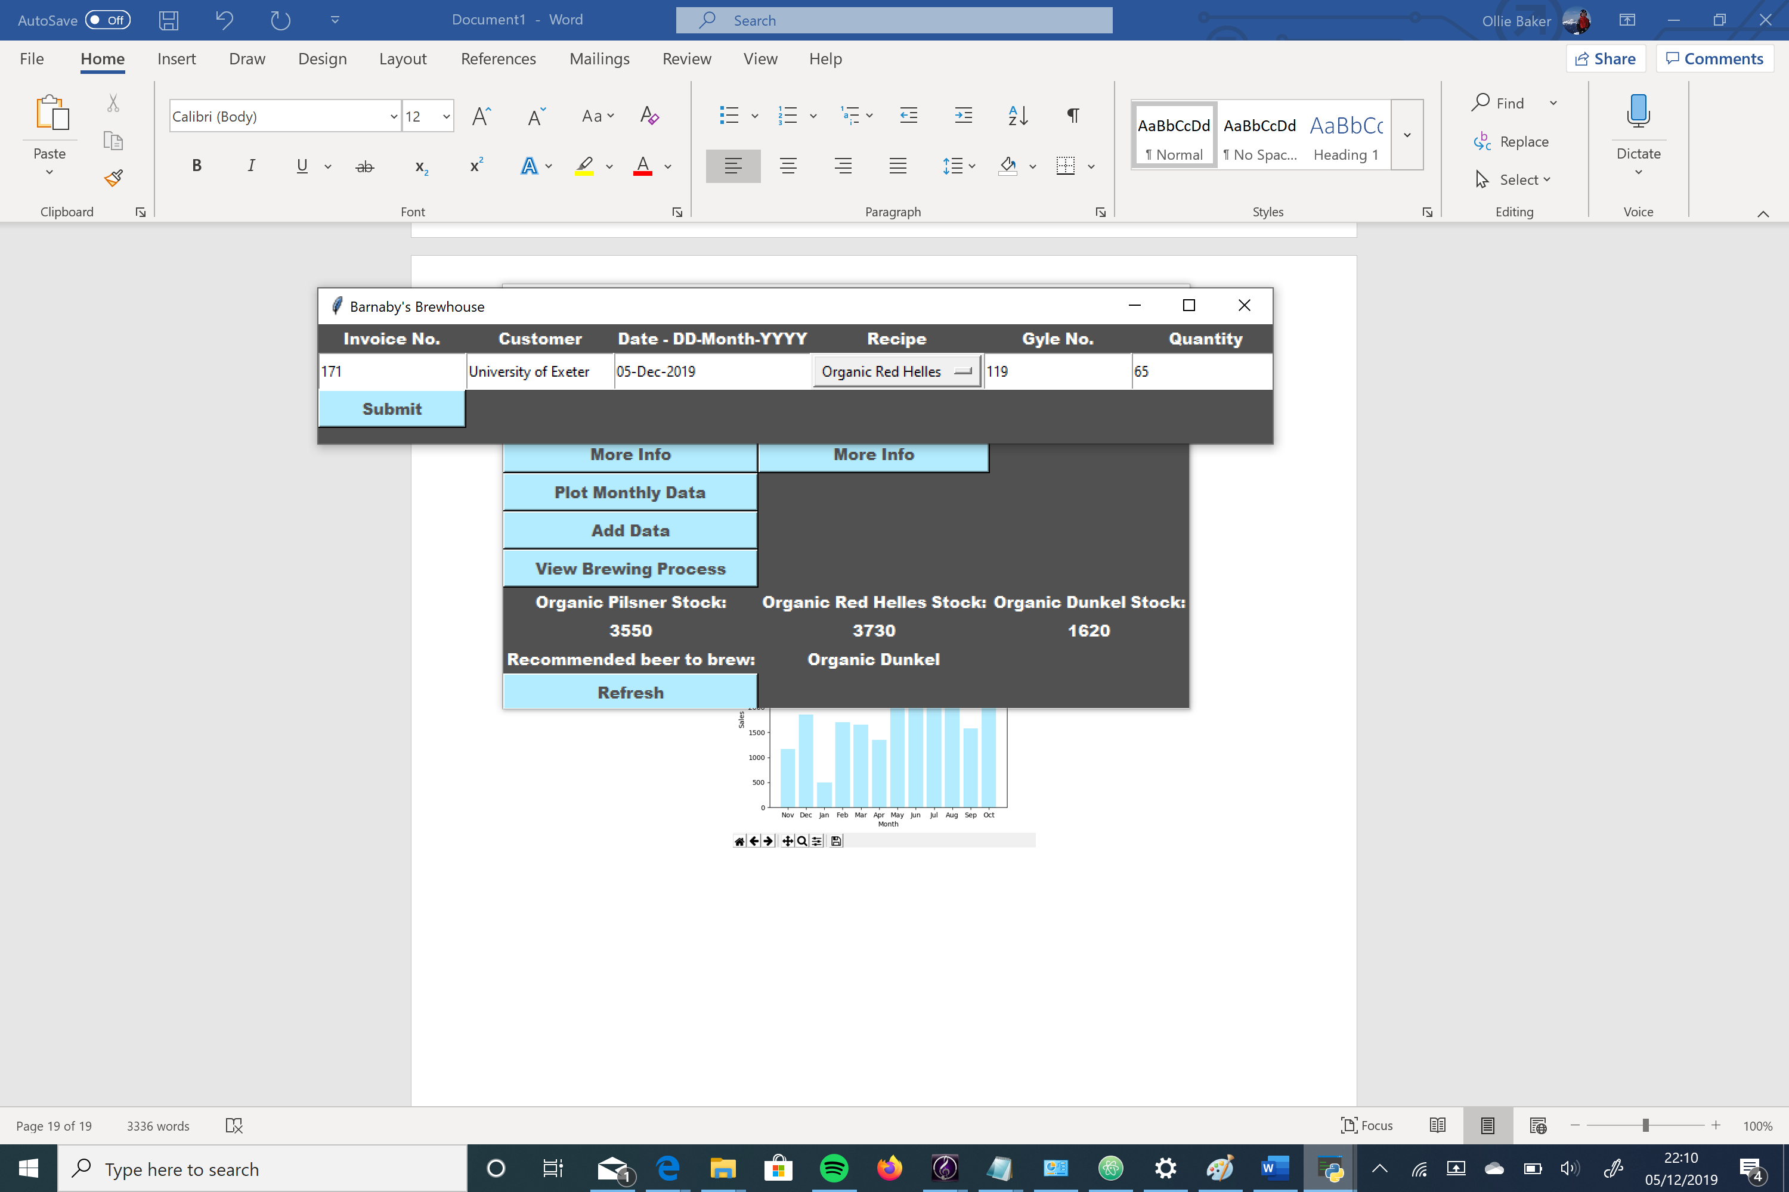

View Brewing Process:

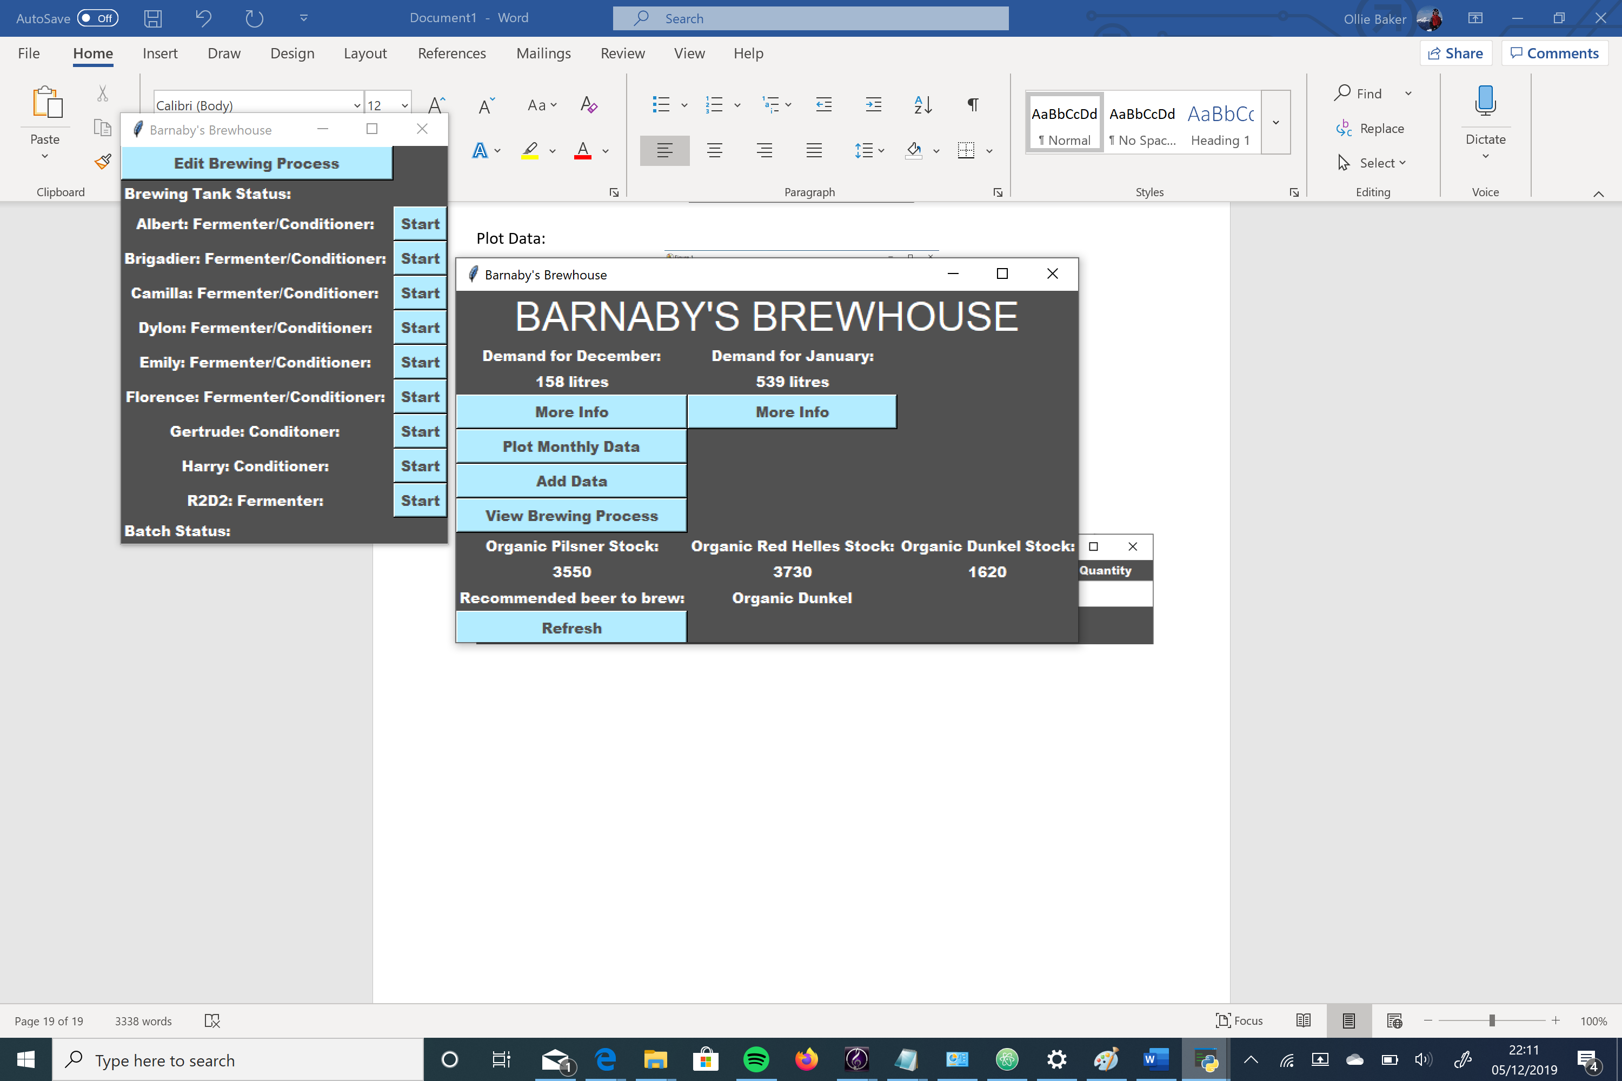

Edit Brewing Process:

